

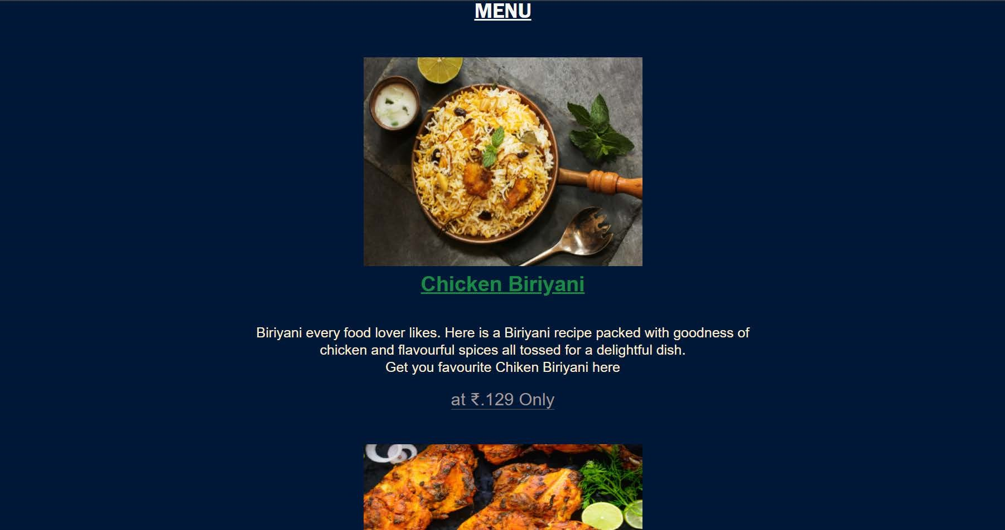

MENU

FOLLOW US



The Tasty Kitchen @ ANANT KHAIRNAR



WEEKEND SPECIAL COMBO

Chicken Combo

Chicken Biriyani + Tandoori

Chicken[2 pcs.] + Gulab

Jamun [2]

Combo For Family

Chicken Biriyani + Mutton Biriyani

Chicken Curry + Boiled Egg[4 pcs.] + Sprite[l ltr]

Order Now

# HOME MENU SERVICES CONTACT US

The Tasty Kitchen - Contact Us

* Required

Email address *

Your email

Full Name *

Your answer

Message *

Your answer

Submit

